

A project Report on

Ambulance Management System

By

Bhagyashree Sonawane(M.C.A.)

**Batch:-** 2020-5078

**Center:-** Pune

### Under the Guidance of,



Technical trainer

# EduBridge

(School of Coding)

# INTRODUCTION:

This Project **Ambulance Management System** has been developed on **Java, JSP and MySQL**. The main purpose for developing this project is to ambulance. In this project **Ambulance Management System in java** Patient can give Facility from any place. This project provides a lots of features to manage in very well manner.

Software Requirement:

|  |  |
| --- | --- |
| **Front end** | **java, servlet, html, css** |
| **Back end** | MySQL |
| **Server** | apacheTomcat8.5V |
| **Ide** | Eclipse Ide for EE developers |
| **Browser** | Google chrome |
| **Operating system** | Windows 10 |

**DATABASE:**

Create database ambdb;

User ambdb;

## Tables:

#### Create tbladmin table:-

#### CREATE TABLE `tbladmin` (

#### `id` bigint NOT NULL AUTO_INCREMENT,

#### `uname` varchar(100) NOT NULL,

#### `upass` varchar(100) DEFAULT NULL,

#### `email` varchar(100) DEFAULT NULL,

#### `added_date` timestamp NOT NULL DEFAULT CURRENT_TIMESTAMP,

#### PRIMARY KEY (`id`)

#### ) ENGINE=InnoDB AUTO_INCREMENT=2 DEFAULT CHARSET=utf8mb4 COLLATE=utf8mb4_0900_ai_ci;

#### Create tblambulance table:-

CREATE TABLE `tblambulance` (

`id` int NOT NULL AUTO_INCREMENT,

`ambulance_vehicle_no` varchar(100) DEFAULT NULL,

`ambulance_type` varchar(45) DEFAULT NULL,

`driver_lincense_no` varchar(100) DEFAULT NULL,

`driver_name` varchar(100) DEFAULT NULL,

`driver_mobile` varchar(100) DEFAULT NULL,

`state` varchar(100) DEFAULT NULL,

`city` varchar(100) DEFAULT NULL,

`status` varchar(45) DEFAULT NULL,

`created_at` timestamp NULL DEFAULT CURRENT_TIMESTAMP,

`updated_at` datetime DEFAULT CURRENT_TIMESTAMP ON UPDATE CURRENT_TIMESTAMP,

PRIMARY KEY (`id`)

) ENGINE=InnoDB AUTO_INCREMENT=5 DEFAULT CHARSET=utf8mb4 COLLATE=utf8mb4_0900_ai_ci;

Create tblcaptcha table:-

CREATE TABLE `tblcaptcha` (

`captcha` varchar(100) DEFAULT NULL

) ENGINE=InnoDB DEFAULT CHARSET=utf8mb4 COLLATE=utf8mb4_0900_ai_ci;

Create tblcontact table:-

CREATE TABLE `tblcontact` (

`contact_id` int NOT NULL AUTO_INCREMENT,

`name` varchar(200) DEFAULT NULL,

`email` varchar(100) DEFAULT NULL,

`mobile` varchar(100) DEFAULT NULL,

`message` varchar(500) DEFAULT NULL,

`created_at` timestamp NULL DEFAULT CURRENT_TIMESTAMP,

PRIMARY KEY (`contact_id`)

) ENGINE=InnoDB AUTO_INCREMENT=3 DEFAULT CHARSET=utf8mb4 COLLATE=utf8mb4_0900_ai_ci;

Create tblcontact table:-

CREATE TABLE `tbldriver` (

`driver_id` varchar(100) NOT NULL,

`driver_name` varchar(200) DEFAULT NULL,

`driver_email` varchar(100) DEFAULT NULL,

`driver_mobile` varchar(100) DEFAULT NULL,

`driver_address` varchar(100) DEFAULT NULL,

`uname` varchar(100) DEFAULT NULL,

`upass` varchar(100) DEFAULT NULL,

`created_at` timestamp NULL DEFAULT CURRENT_TIMESTAMP,

`updated_at` datetime DEFAULT CURRENT_TIMESTAMP ON UPDATE CURRENT_TIMESTAMP,

PRIMARY KEY (`driver_id`)

) ENGINE=InnoDB DEFAULT CHARSET=utf8mb4 COLLATE=utf8mb4_0900_ai_ci;

Create tbldriver table:-

CREATE TABLE `tbldriver` (

`driver_id` varchar(100) NOT NULL,

`driver_name` varchar(200) DEFAULT NULL,

`driver_email` varchar(100) DEFAULT NULL,

`driver_mobile` varchar(100) DEFAULT NULL,

`driver_address` varchar(100) DEFAULT NULL,

`uname` varchar(100) DEFAULT NULL,

`upass` varchar(100) DEFAULT NULL,

`created_at` timestamp NULL DEFAULT CURRENT_TIMESTAMP,

`updated_at` datetime DEFAULT CURRENT_TIMESTAMP ON UPDATE CURRENT_TIMESTAMP,

PRIMARY KEY (`driver_id`)

) ENGINE=InnoDB DEFAULT CHARSET=utf8mb4 COLLATE=utf8mb4_0900_ai_ci;

***Modules of Ambulance Management System***

* Login page
* Home page
* Order place page
* History of shopping

Before help for Ambulance user should have to register first. Then user should login with the credentials. There are many things to provide facility. Let’s see….

* Home page:

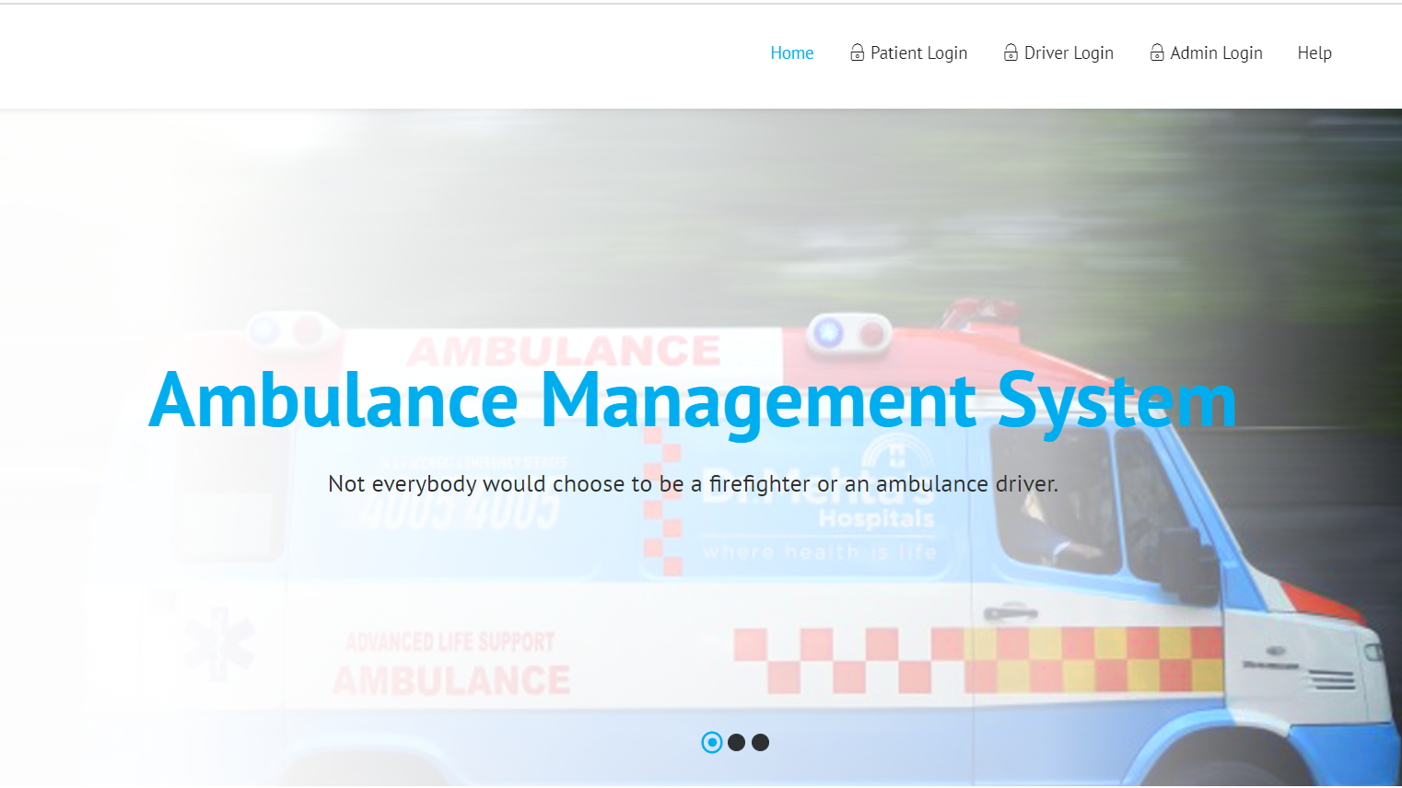

* Patient Login page:

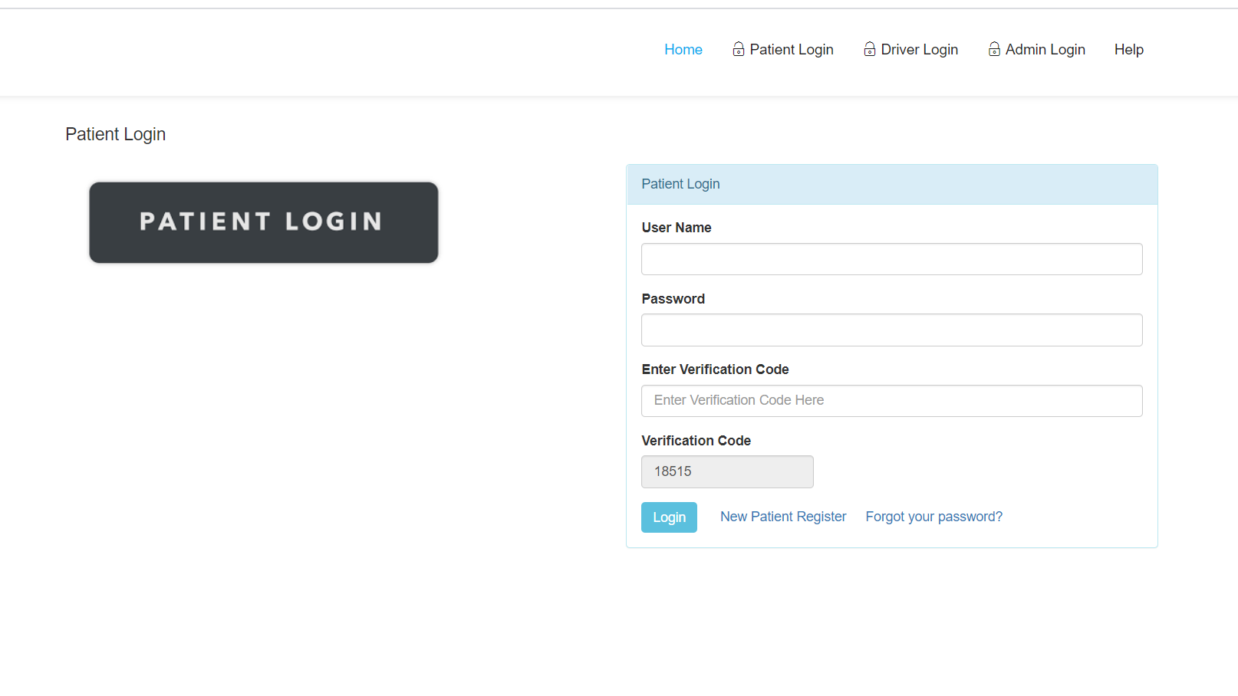

* Driver Login page:

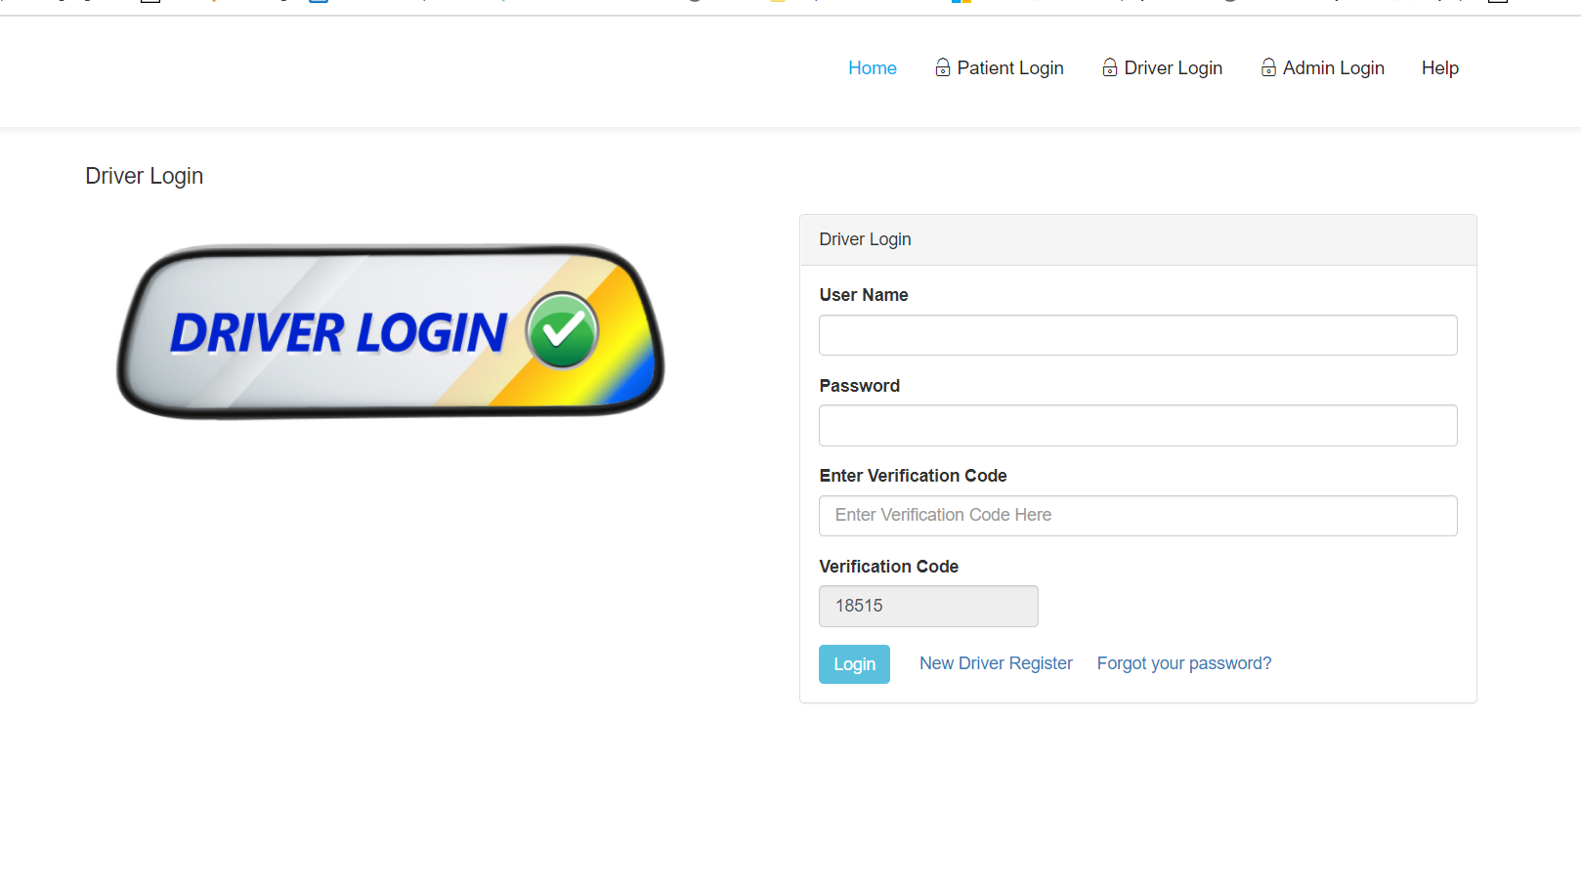

* Admin Login page:

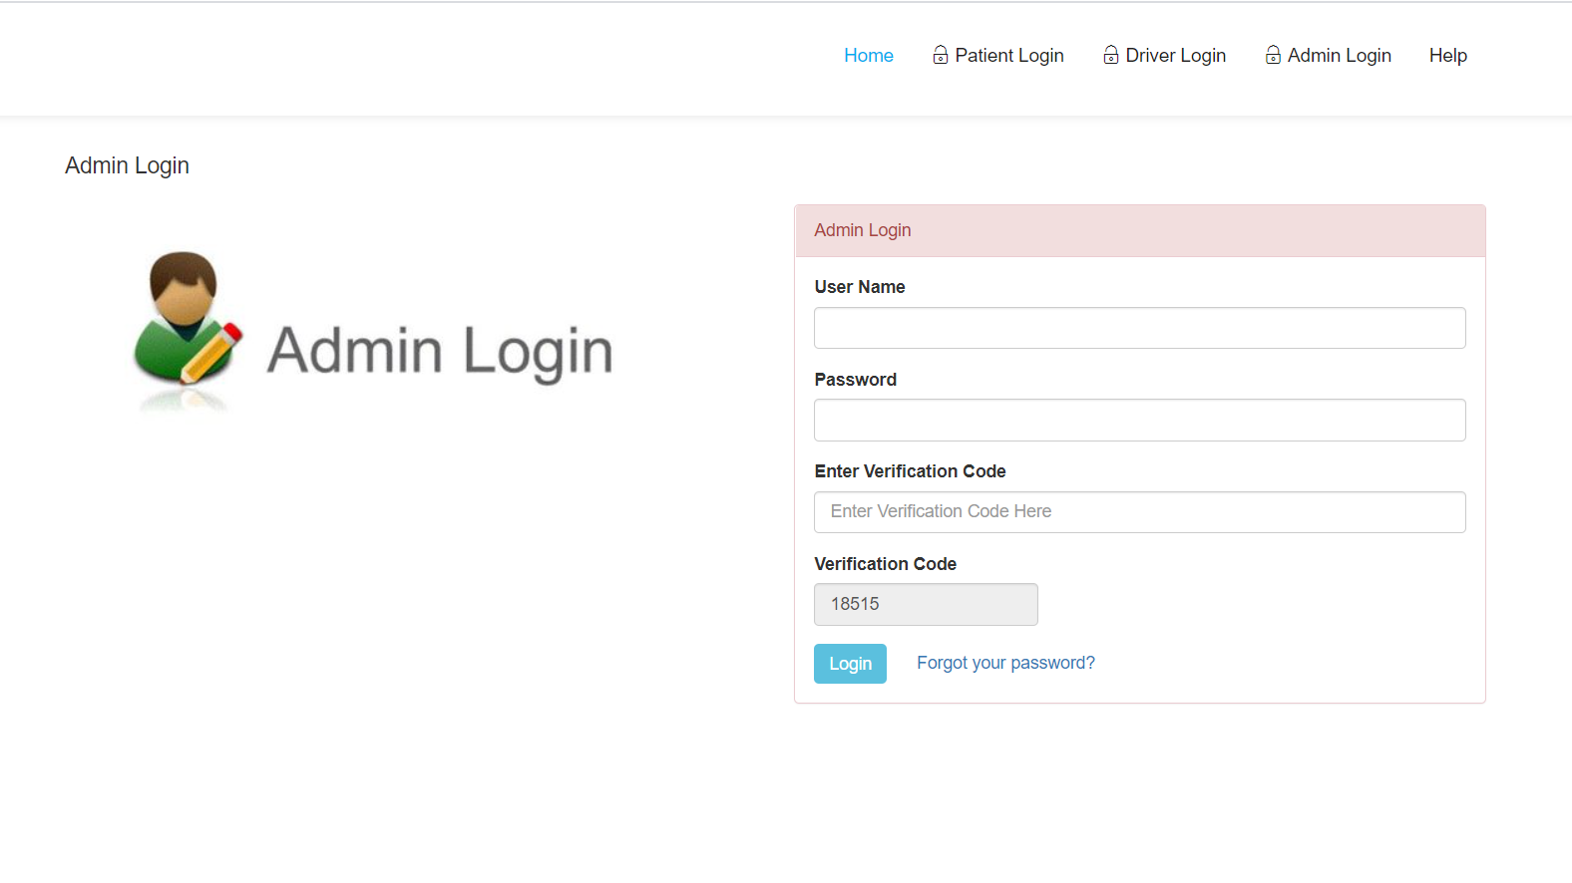

* Help page:

